PIPES AND DIRECTION ASSIGNMENT

(LINUX ENVIRONMENT VARIABLE ASSIGNMENT)

1.Create a script named “myscript” in current directory to do the following.

a) create a dir named “subd1” in current directory

mkdir myscript

vi myscript.sh

cat vi myscript

mkdir myscript/subd1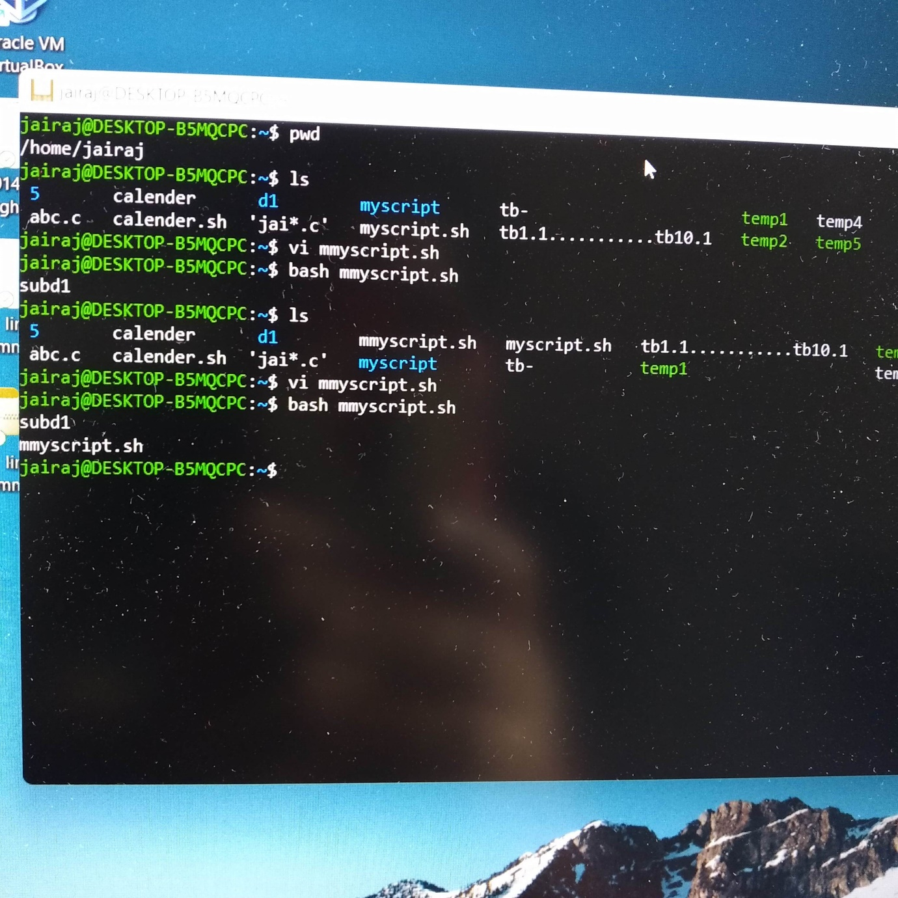

b) create a file named “dircontent” with contents of the current directory

vi dircontent.sh

bash dircontent.sh

./bash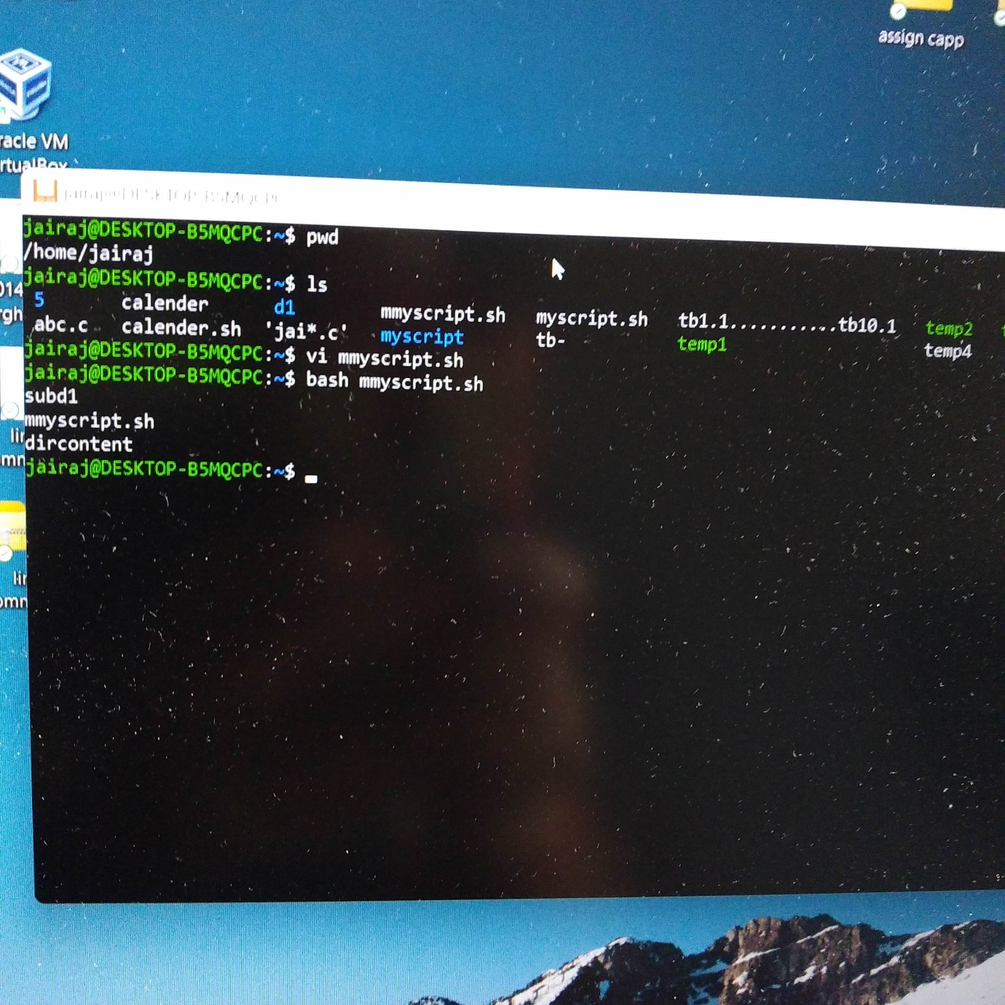

c) display the contents of the file “dircontent”

echo $dircontent

d) display the contents of a non existing file named “unknownfile”

vi unknownfile.sh

bash unknownfile.sh

echo $unknownfile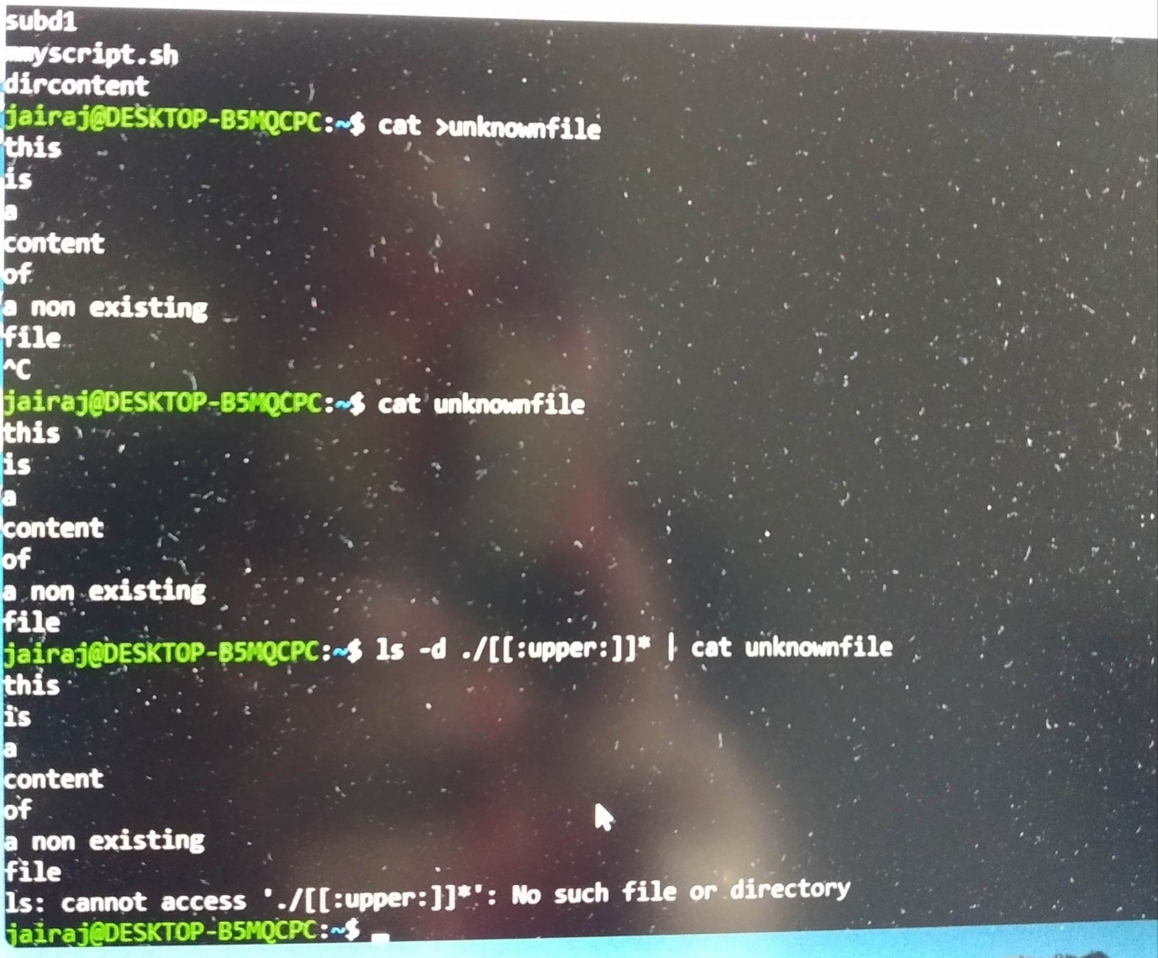

2. Run the script and validate the output in following cases

a) Redirect only the stdout to an o/p file named stdout.txt

cat < stdout.text

//the input will be display in terminal

cat l< stdout.text > fileout

cat fileout

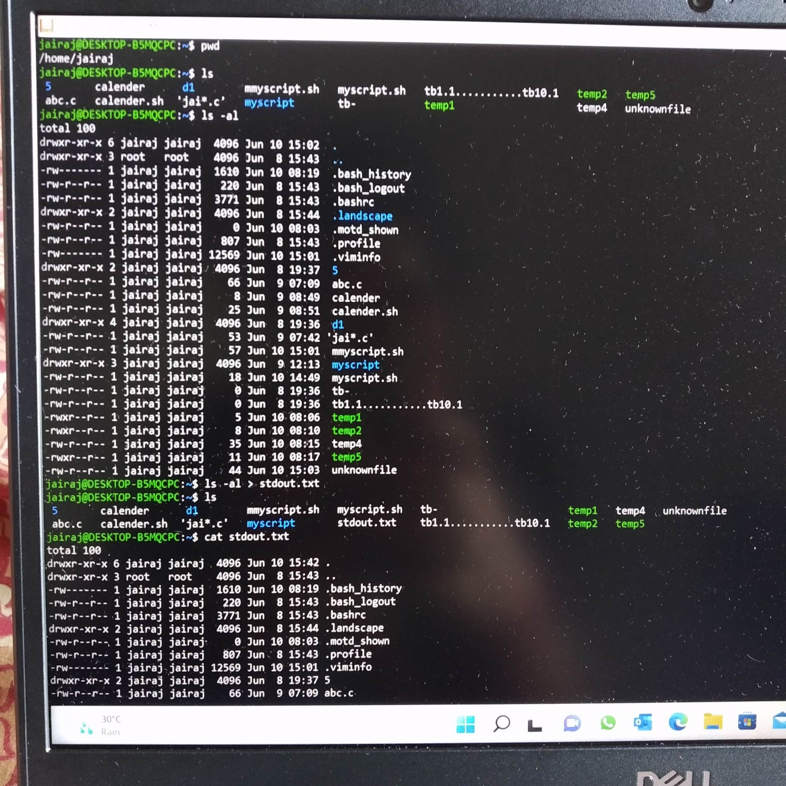

b) Redirect only the stderr to an o/p file named stderr.txt

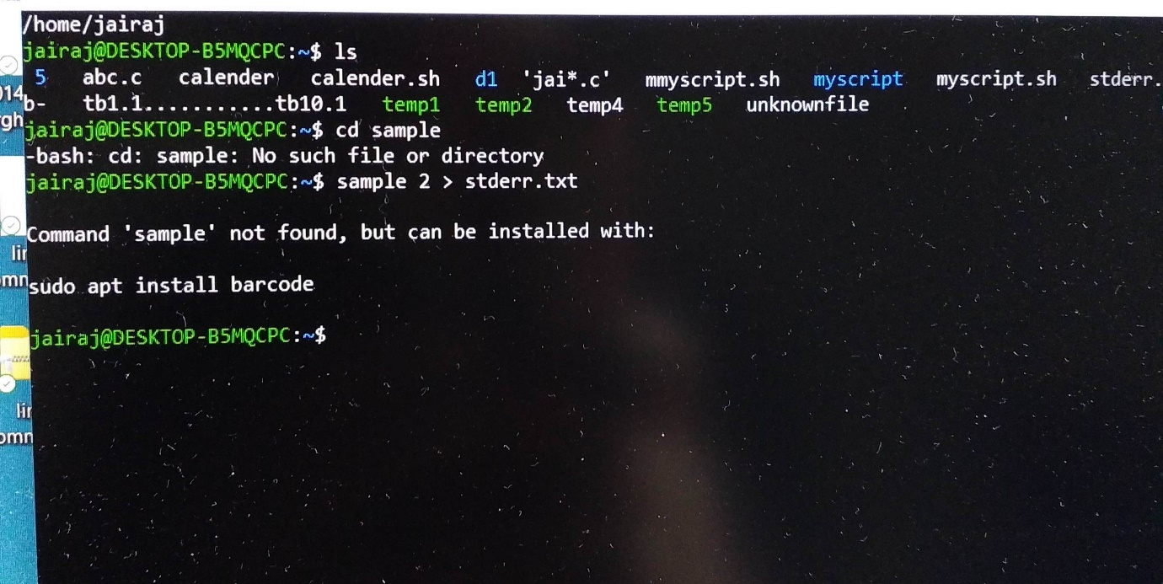

2. c.Redirect both stdout and stderr to an o/p file named stdall.txt

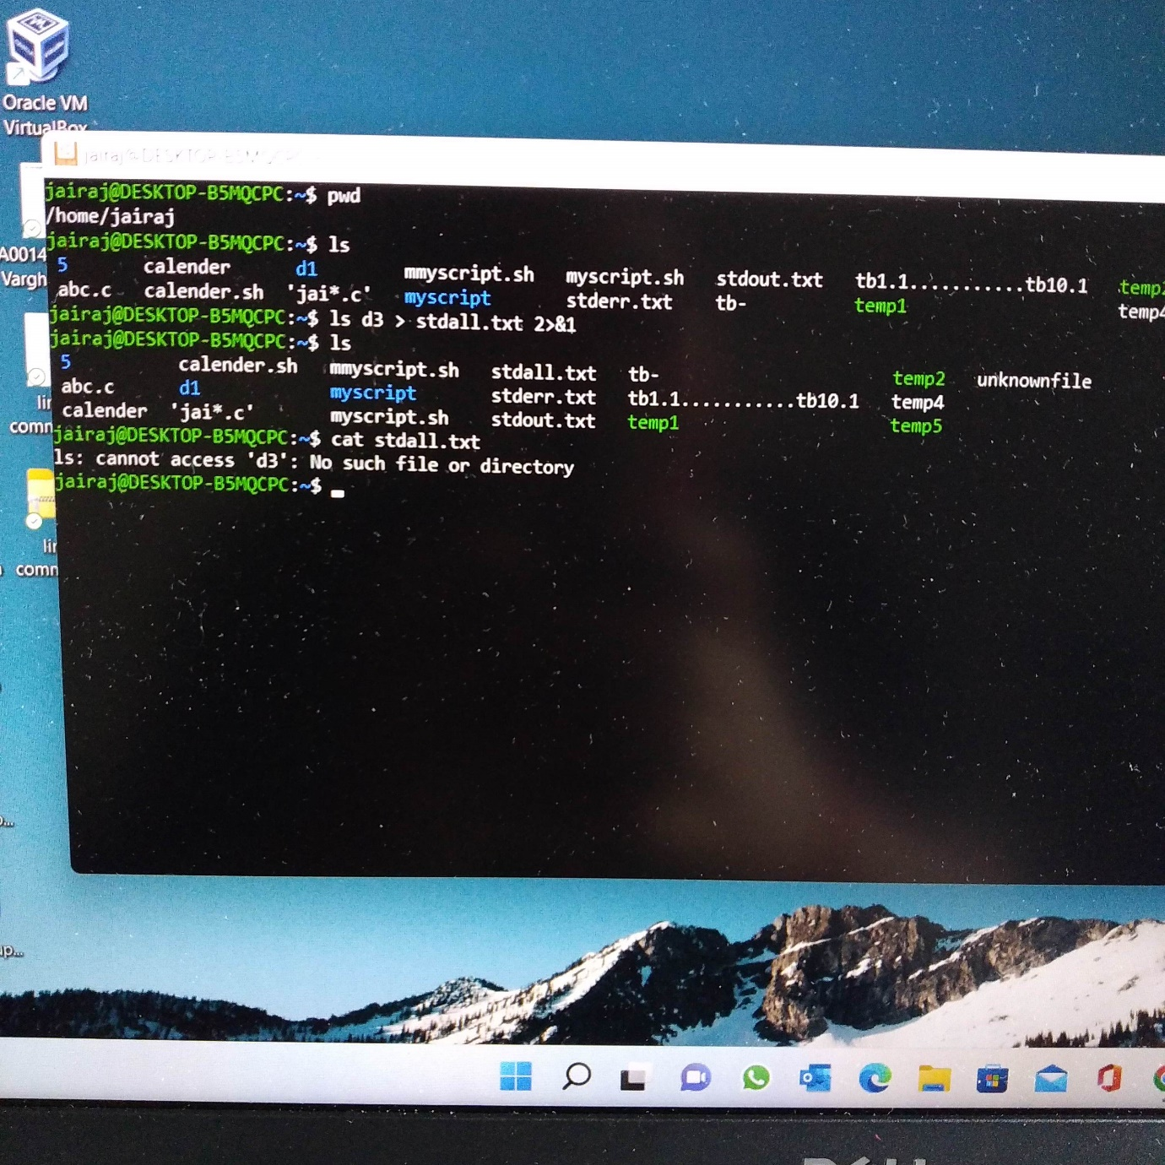

2 d. Display all o/p and error and also redirect both stdout and stderr to an o/p file named stdall.txt

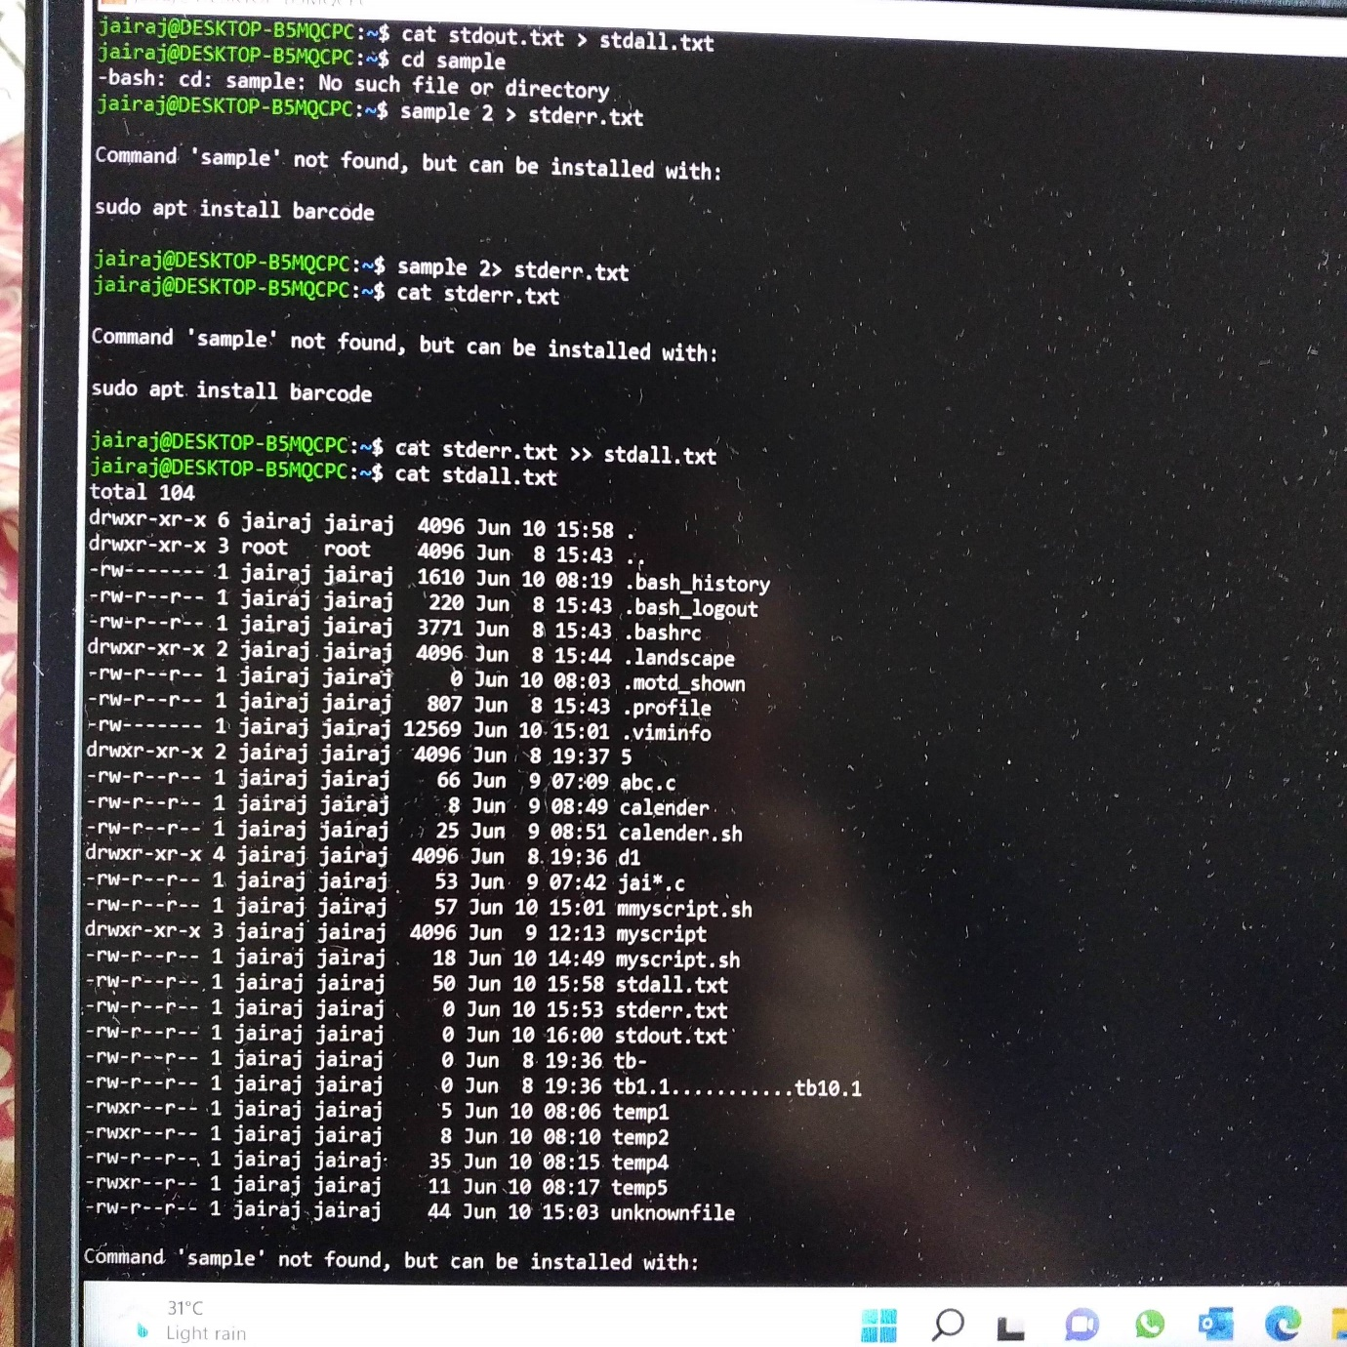

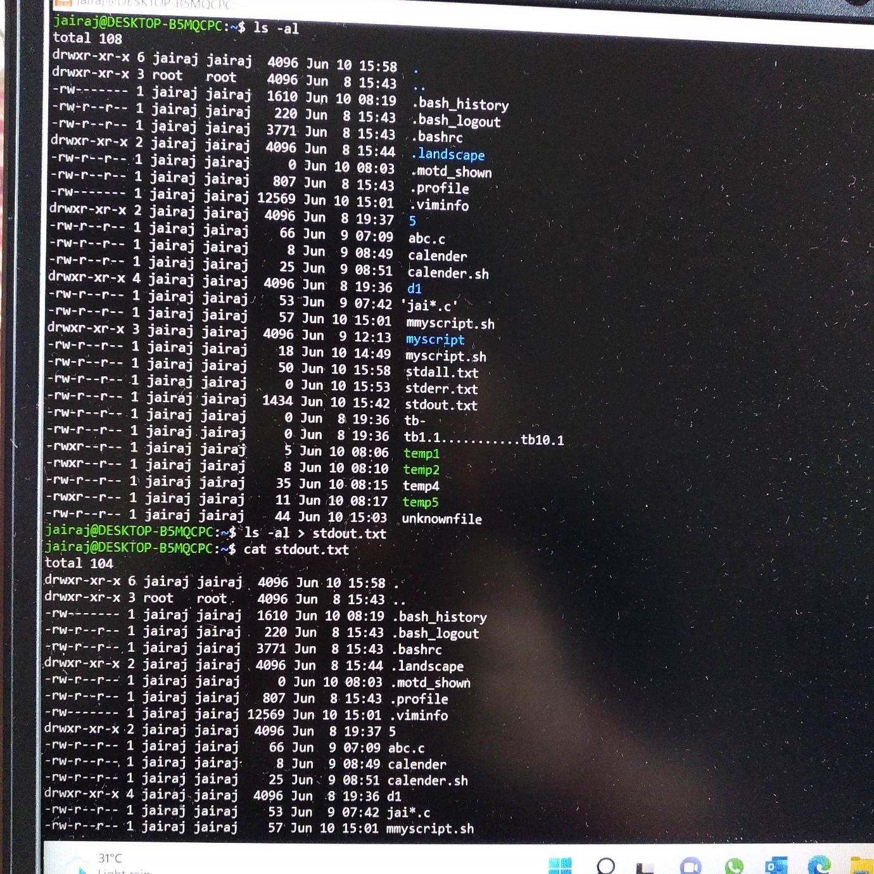

3. Redirct the output of command below using pipe (|) to wc and get the output .

